Power Supply Power Cables
Thelio Main
Spec version 2

All wire lengths specified from the inside of the connectors.

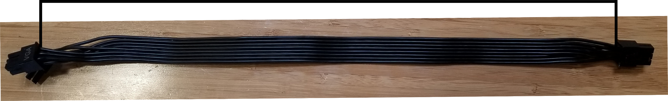

Cables and connectors are are to be black. Cables are to be braided.
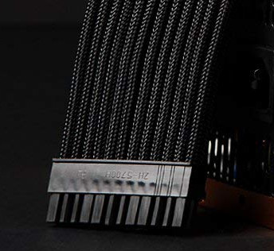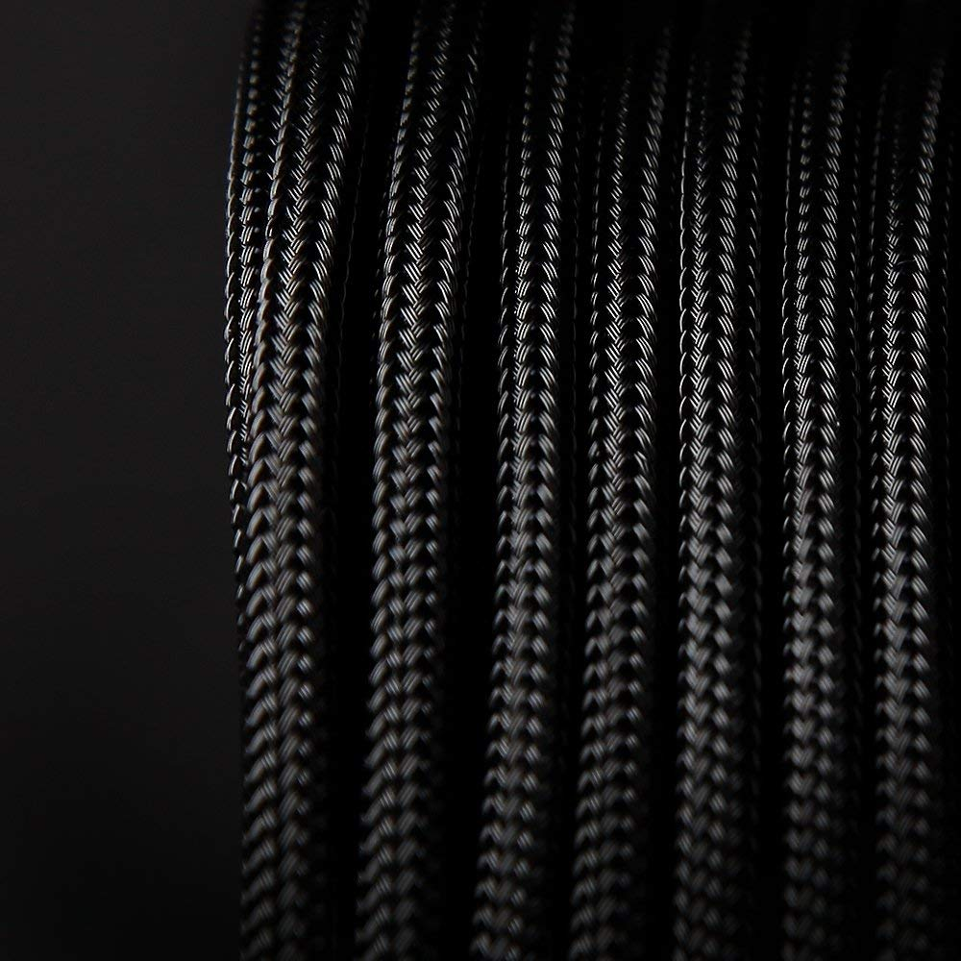

CPU Power - 520mm

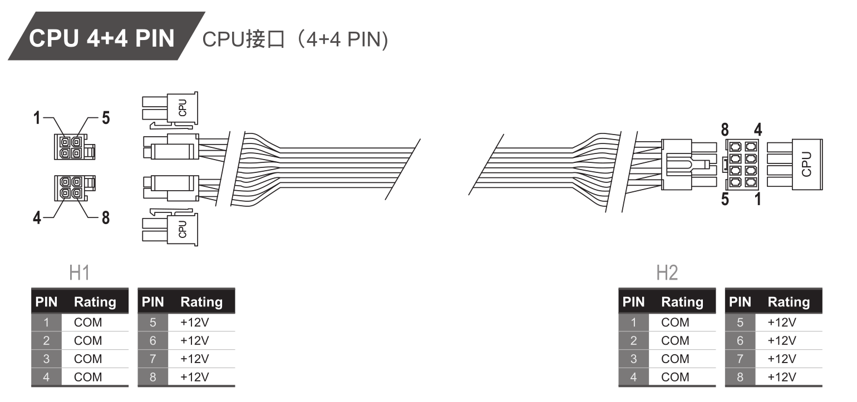
Mainboard Power - 440mm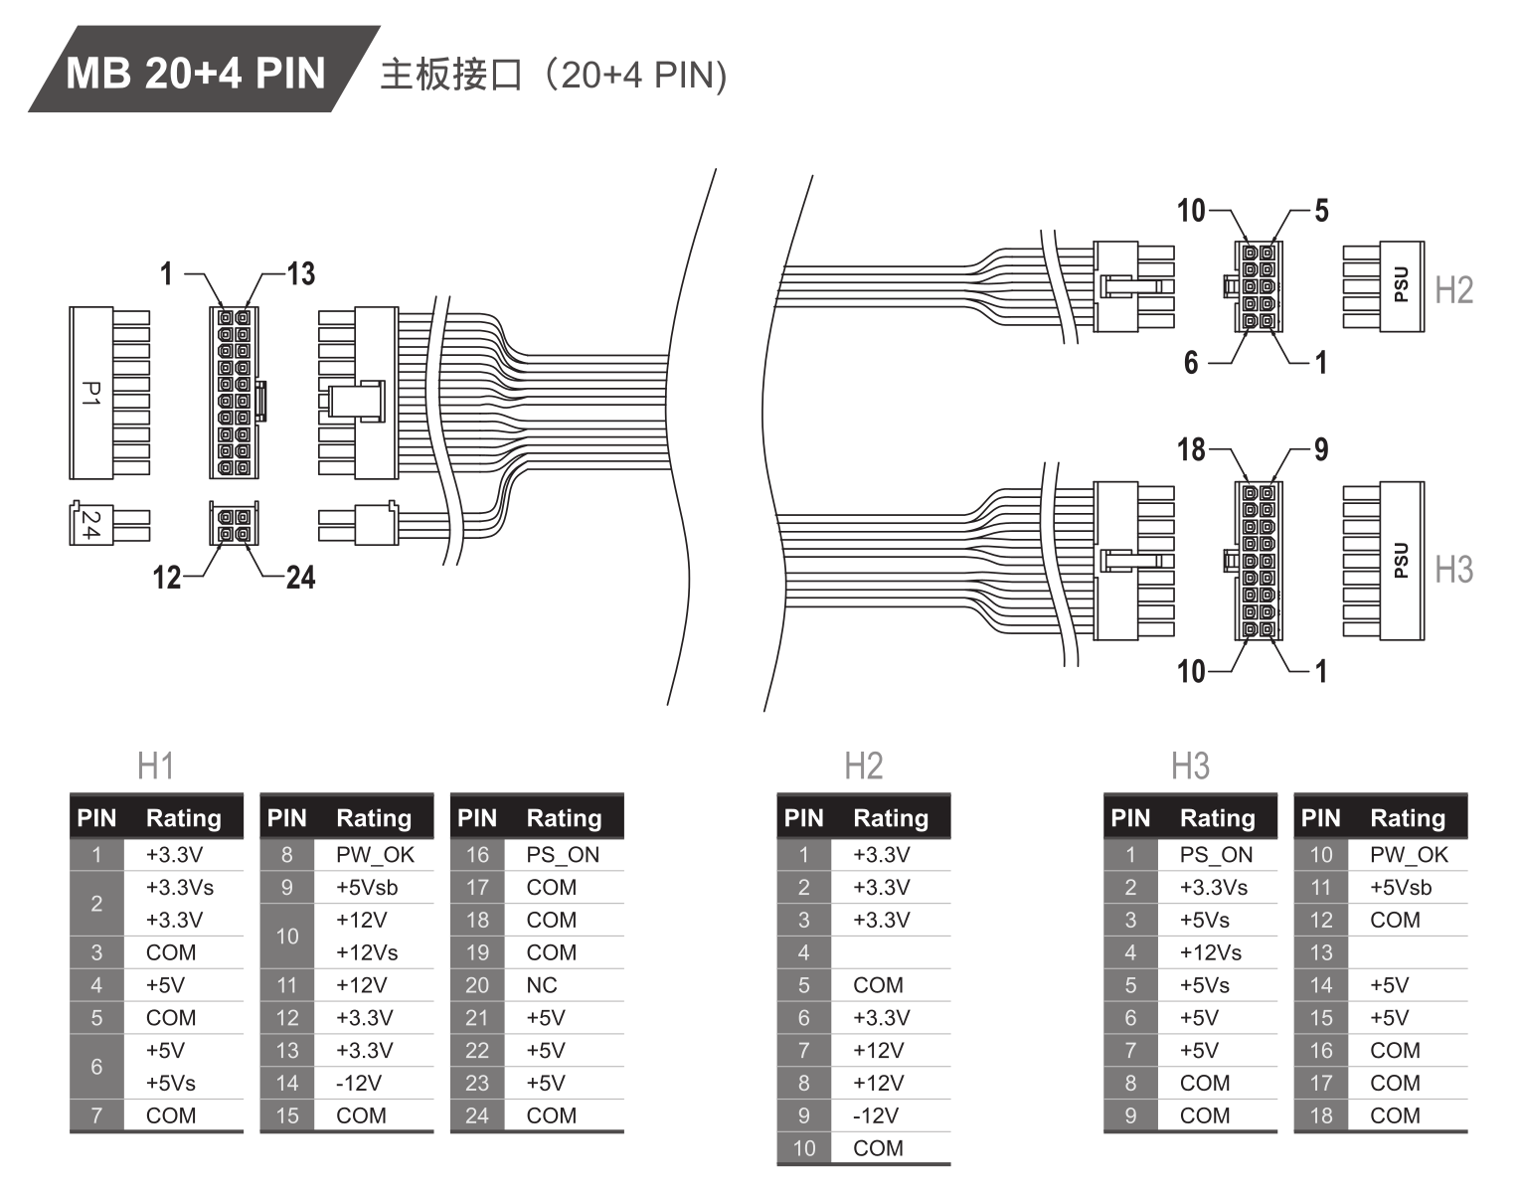
VGA - 235mm UPDATED - 6 pin PS connector

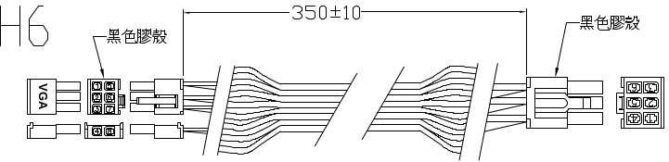
1 5 6 3
2 6 5 2
3 7 4 1
4 8
Floppy connector - UPDATED - 270mm
